------------------ASSIGNMENT-SQL-------------------

QUERIES(1-10)

1.*Write a query which will display the customer id, account type they hold, their account number and bank name.

SELECT A.CUSTOMER_ID,A.ACCOUNT_TYPE,A.ACCOUNT_NO,B.BANK_NAME

FROM ACCOUNT_INFO A,BANK_INFO B

WHERE A.IFSC_CODE=B.IFSC_CODE;

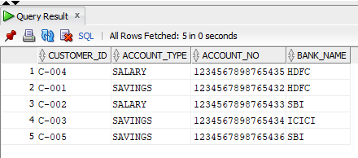

2.*Write a query which will display the customer id, account type and the account number of HDFC customers who registered after 12-JAN-2012 and before 04-APR-2012.

SELECT CUSTOMER_ID,ACCOUNT_TYPE,ACCOUNT_NO

FROM ACCOUNT_INFO A

WHERE IFSC_CODE=(SELECT IFSC_CODE FROM BANK_INFO WHERE BANK_NAME='HDFC') AND REGISTRATION_DATE BETWEEN '12-JAN-2012' AND '04-APR-2012';

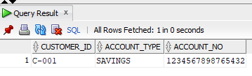

3.*Write a query which will display the customer id, customer name, account no, account type and bank name where the customers hold the account.

SELECT C.CUSTOMER_ID,C.CUSTOMER_NAME,A.ACCOUNT_NO,A.ACCOUNT_TYPE,B.BANK_NAME

FROM CUSTOMER_PERSONAL_INFO C,ACCOUNT_INFO A,BANK_INFO B

WHERE C.CUSTOMER_ID=A.CUSTOMER_ID AND A.IFSC_COED=B.IFSC_CODE;

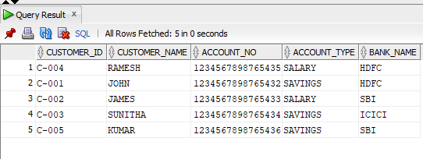

4.*Write a query which will display the customer id, customer name, gender, marital status along with the unique reference string and

sort the records based on customer id in descending order. <br/>

<br/><b>Hint: </b>Generate unique reference string as mentioned below

:

<br/> CustomerName_Gender_MaritalStatus

<br/><b> Example, </b>

<br/> C-005 KUMAR M SINGLE KUMAR_M_SINGLE

<BR/>

Use ""UNIQUE_REF_STRING"" as alias name for displaying the unique reference string."

SELECT CUSTOMER_ID,CUSTOMER_NAME,GENDER,MARITAL_STATUS,CUSTOMER_NAME||"_"||GENDER||"_"||MARITAL_STATUS AS UNIQUE_REF_STRING

FROM CUSTOMER_PERSONAL_INFO

ORDER BY CUSTOMER_ID DESC;

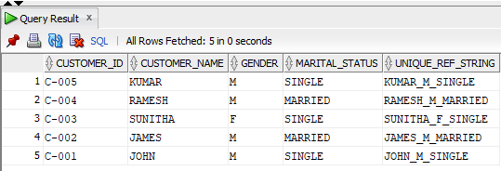

5.*Write a query which will display the account number, customer id, registration date, initial deposit amount of the customer whose initial deposit amount is within the range of Rs.15000 to Rs.25000.

SELECT ACCOUNT_NO,CUSTOMER_ID,REGISTRATION_DATE,INITIAL_DEPOSIT

FROM ACCOUNT_INFO

WHERE INITIAL_DEPOSIT BETWEEN 15000 AND 25000;

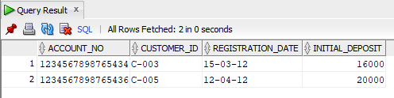

6.*Write a query which will display customer id, customer name, date of birth, guardian name of the customers whose name starts with 'J'.

SELECT CUSTOMER_ID,CUSTOMER_NAME,DATE_OF_BIRTH,GUARDIAN_NAME

FROM CUSTOMER_PERSONAL_INFO

WHERE CUSTOMER_NAME LIKE 'J%';

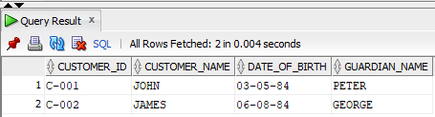

7.*Write a query which will display customer id, account number and passcode.

<br/>

Hint: To generate passcode, join the last three digits of customer id and last four digit of account number.

<br/>Example

<br/>C-001 1234567898765432 0015432

<br/>Use ""PASSCODE"" as alias name for displaying the passcode."

SELECT CUSTOMER_ID,ACCOUNT_NO,SUBSTR(CUSTOMER_ID,'-',3)||SUBSTR(ACCOUNT_NO,12,4) AS PASSCODE

FROM ACCOUNT_INFO;

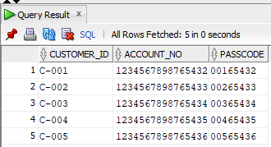

8.*Write a query which will display the customer id, customer name, date of birth, Marital Status, Gender, Guardian name,

contact no and email id of the customers whose gender is male 'M' and marital status is MARRIED.

SELECT CUSTOMER_ID,CUSTOMER_NAME,DATE_OF_BIRTH,MARITAL_STATUS,GENDER,GUARDIAN_NAME,CONTACT_NO,MAIL_ID

FROM CUSTOMER_PERSONAL_INFO

WHERE GENDER='M' AND MARITAL_STATUS='MARRIED';

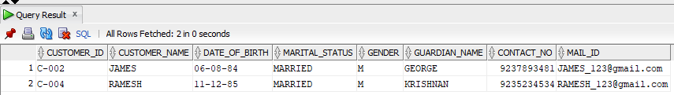

9.*Write a query which will display the customer id, customer name, guardian name, reference account holders name of the customers

who are referenced / referred by their 'FRIEND'.

SELECT C.CUSTOMER_ID,C.CUSTOMER_NAME,C.GUARDIAN_NAME,R.REFERENCE_ACC_NAME

FROM CUSTOMER_PERSONAL_INFO C, CUSTOMER_REFERENCE_INFO R

WHERE C.CUSTOMER_ID=R.CUSTOMER_ID AND RELATION='FRIEND';

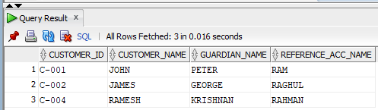

10.*Write a query to display the customer id, account number and interest amount in the below format with INTEREST_AMT as alias name

Sort the result based on the INTEREST_AMT in ascending order. <BR/>Example:

$5<BR/>Hint: Need to prefix $ to interest amount and round the result without decimals.

SELECT CUSTOMER_ID,ACCOUNT_NO,$||ROUND((INTEREST/100)*INITIAL_DEPOSIT) AS INTEREST_AMOUNT

FROM ACCOUNT_INFO

ORDER BY INTEREST_AMOUNT;

